Lab Experiments

1.Code:
import random

GOAL = [1,2,3,4,5,6,7,8,0] # 0 is the empty space

def print_board(b):
for i in range(0,9,3):
print(' '.join(' ' if x==0 else str(x) for x in b[i:i+3]))
print()

def inversions(arr):
a = [x for x in arr if x!=0]
inv = 0
for i in range(len(a)):
for j in range(i+1,len(a)):
if a[i] > a[j]:
inv += 1
return inv

def is_solvable(arr):
return inversions(arr) % 2 == 0

def scramble():
while True:
b = GOAL[:]
random.shuffle(b)
if is_solvable(b) and b != GOAL:
return b

def neighbors(idx):
r, c = divmod(idx, 3)
res = []
for dr,dc in [(-1,0),(1,0),(0,-1),(0,1)]:
nr, nc = r+dr, c+dc
if 0 <= nr < 3 and 0 <= nc < 3:
res.append(nr*3 + nc)
return res

def play():
board = scramble()
print("8-Puzzle — slide tiles to reach:")
print_board(GOAL)
steps = 0
while True:
print("Current board:")
print_board(board)
if board == GOAL:
print(f"Solved in {steps} moves — well done!")
break
cmd = input("Enter tile number to move (or 'q' to quit): ").strip()
if cmd.lower() == 'q':
print("Quitting. Bye!")
break
if not cmd.isdigit():
print("Please enter a number 1-8.")
continue
tile = int(cmd)
if tile < 1 or tile > 8:
print("Choose a tile between 1 and 8.")
continue
try:
t_idx = board.index(tile)
z_idx = board.index(0)
except ValueError:
print("Tile not found — unexpected error.")
continue
if t_idx in neighbors(z_idx):
board[z_idx], board[t_idx] = board[t_idx], board[z_idx]
steps += 1
else:
print("That tile can't move into the empty space. Choose an adjacent tile.")

if __name__ == "__main__":
play()
Output: 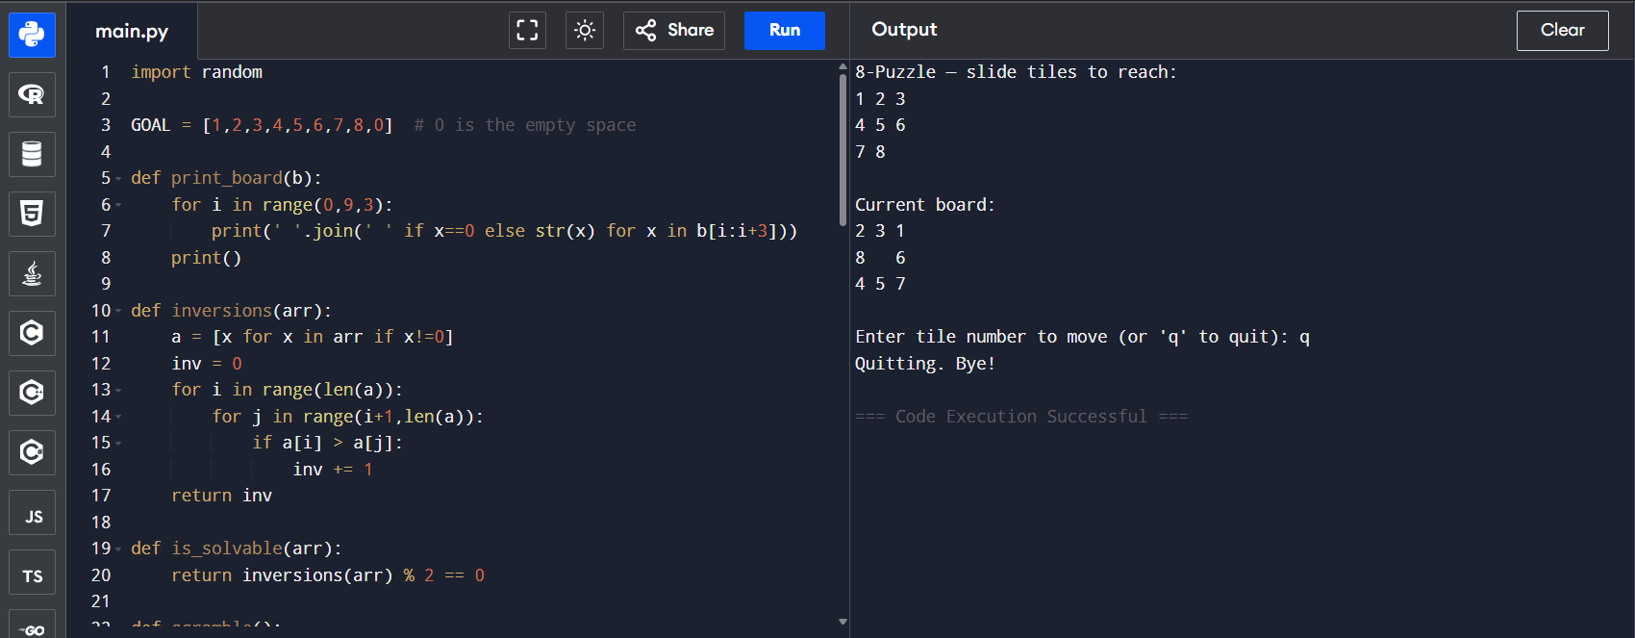

2.Code:
def hanoi(n, source, helper, target):
if n == 1:
print("Move disk 1 from", source, "to", target)
return
hanoi(n-1, source, target, helper)
print("Move disk", n, "from", source, "to", target)
hanoi(n-1, helper, source, target)

n = int(input("Enter number of disks: "))
print("Steps to solve Towers of Hanoi:")
hanoi(n, 'A', 'B', 'C')

Output:
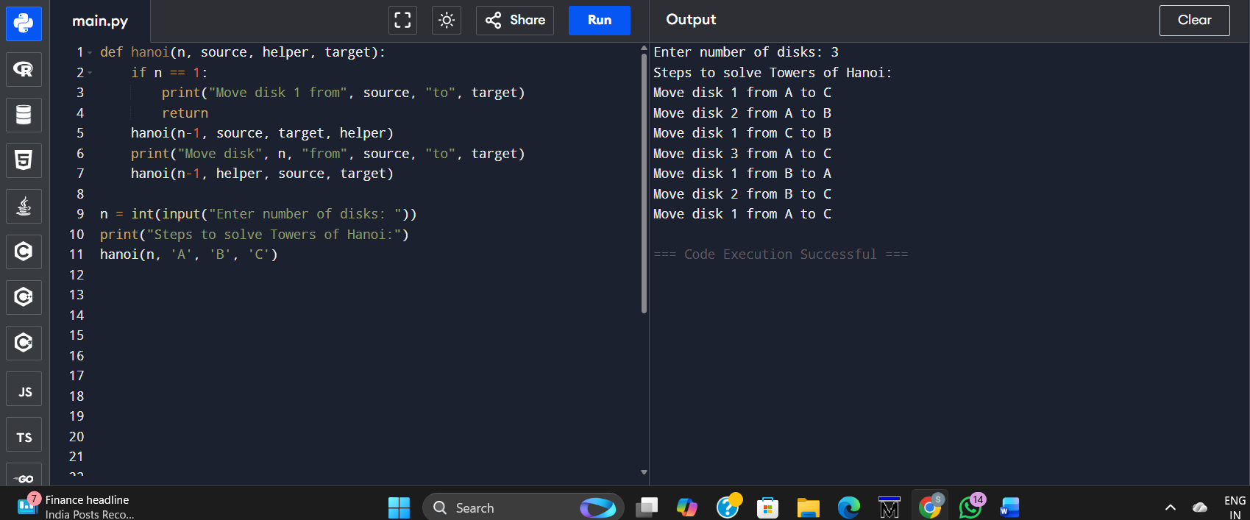

3.Code:
from collections import deque

def bfs(graph, start):
visited = set()
queue = deque([start])

while queue:
node = queue.popleft()
if node not in visited:
print(node, end=" ")
visited.add(node)
for neigh in graph[node]:
if neigh not in visited:
queue.append(neigh)

graph = {
'A': ['B', 'C'],
'B': ['D', 'E'],
'C': ['F'],
'D': [],
'E': ['F'],
'F': []
}

start_node = 'A'
print("BFS Traversal:")
bfs(graph, start_node)
Output:
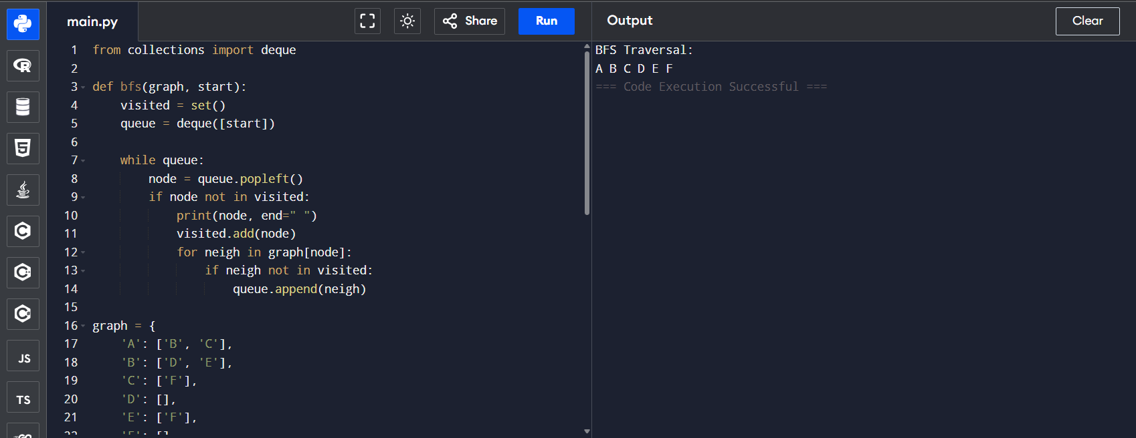
4.Code:
def monkey_problem():
state = {
"monkey": "door",
"box": "window",
"monkey_on_box": False,
"has_banana": False
}

print("Initial State:", state)

state["monkey"] = "middle"
print("Monkey moves to middle:", state)

state["box"] = "middle"
print("Monkey pushes box to middle:", state)

state["monkey_on_box"] = True
print("Monkey climbs on box:", state)

state["has_banana"] = True
print("Monkey takes banana:", state)

print("\nFinal State:", state)

monkey_problem()
Output :
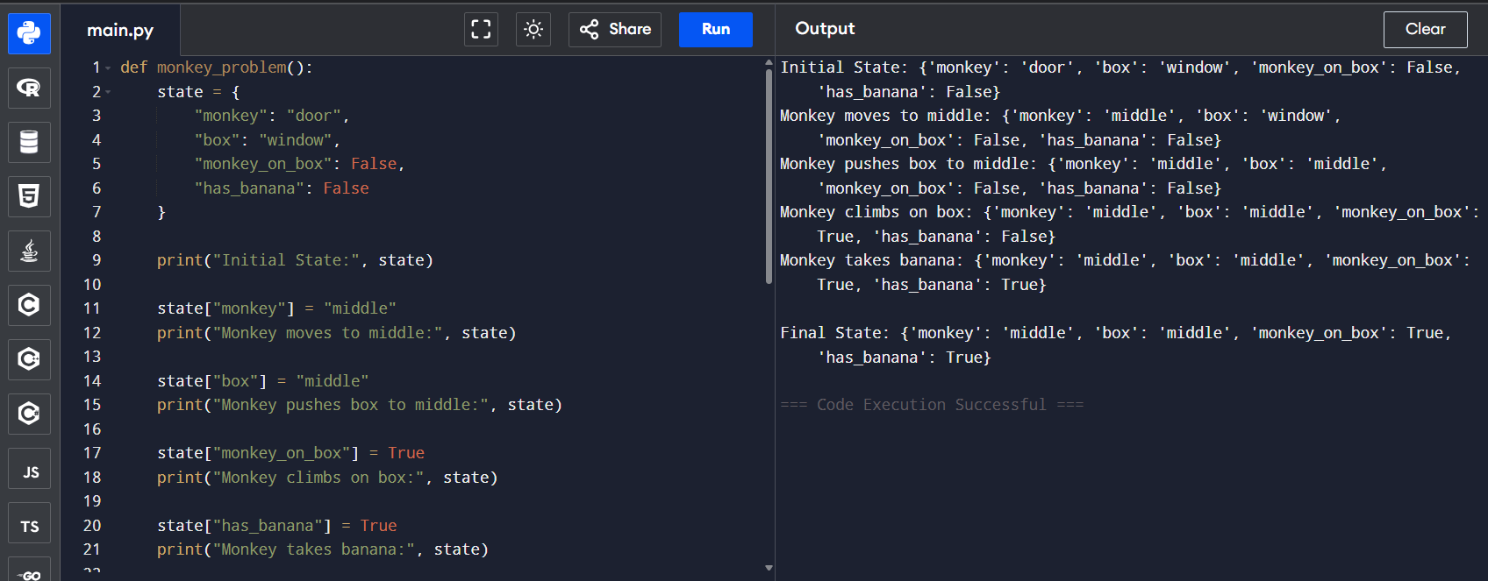
5.Code :
def solve_n_queens(n=8):
solutions = []
def backtrack(row, cols, diag1, diag2, pos):
if row == n:
solutions.append(pos[:])
return
for col in range(n):
if col in cols or (row-col) in diag1 or (row+col) in diag2:
continue
cols.add(col); diag1.add(row-col); diag2.add(row+col)
pos.append(col)
backtrack(row+1, cols, diag1, diag2, pos)
pos.pop()
cols.remove(col); diag1.remove(row-col); diag2.remove(row+col)

backtrack(0, set(), set(), set(), [])
return solutions

def print_board(solution):
n = len(solution)
for r in range(n):
row = ['.'] * n
row[solution[r]] = 'Q'
print(' '.join(row))
print()

if __name__ == "__main__":
sols = solve_n_queens(8)
print("Number of solutions:", len(sols))
for i, sol in enumerate(sols, 1):
print("Solution", i)
print_board(sol)
Output:
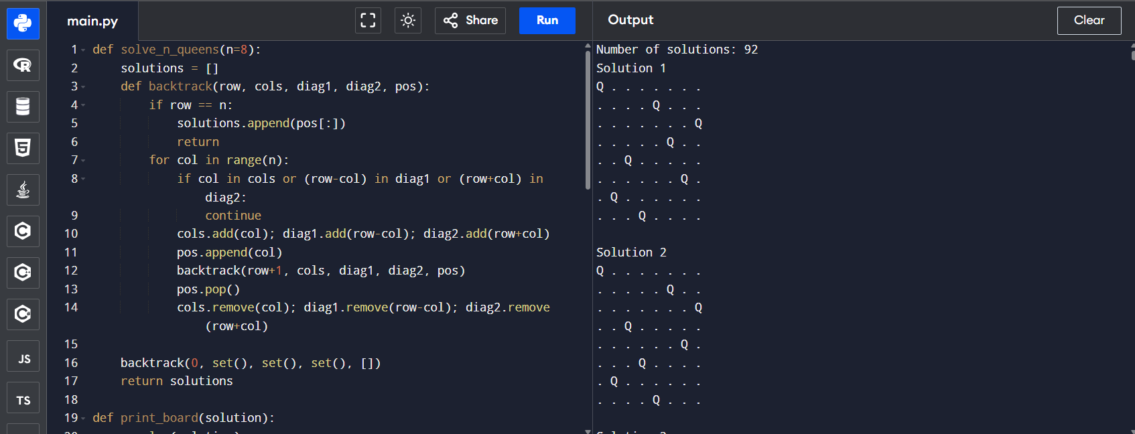

6.Code:
def dfs(graph, start, visited=None):
if visited is None:
visited = set()
print(start, end=" ")
visited.add(start)

for neigh in graph[start]:
if neigh not in visited:
dfs(graph, neigh, visited)

graph = {
'A': ['B', 'C'],
'B': ['D', 'E'],
'C': ['F'],
'D': [],
'E': ['F'],
'F': []
}

print("DFS Traversal:")
dfs(graph, 'A')
Output:
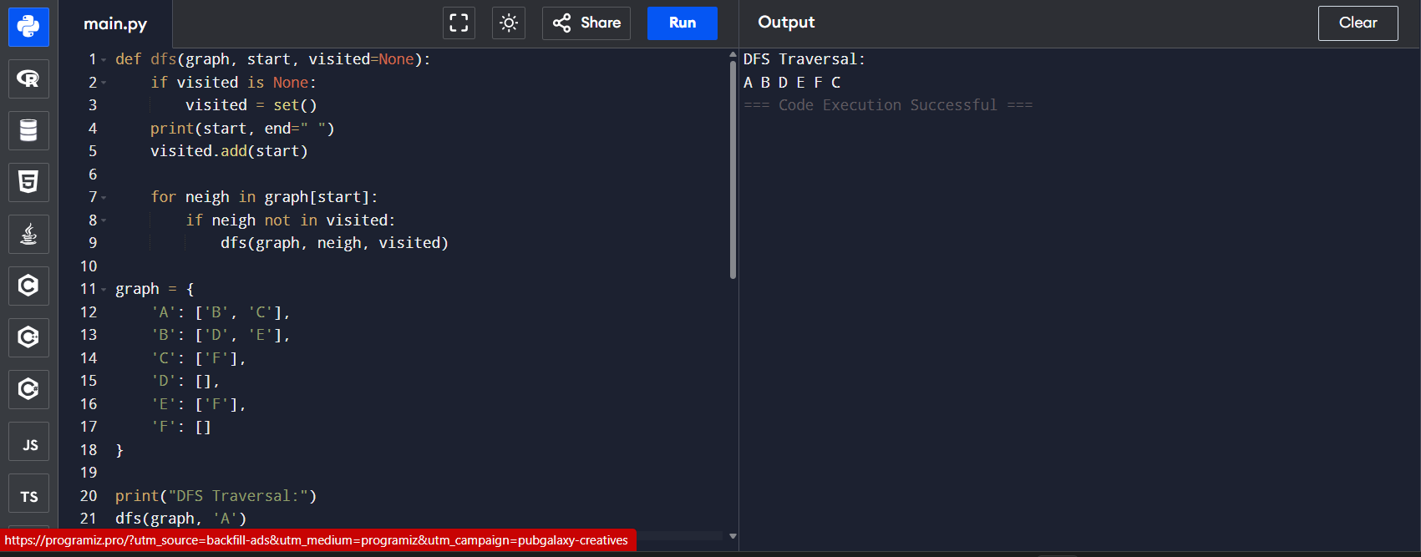7.Code:
from collections import deque

def bfs_solve(capA, capB, target):
start = (0, 0)
q = deque([start])
visited = {start}
parent = {start: None}
action = {start: "Start"}

while q:
a, b = q.popleft()
if a == target:
path = []
cur = (a, b)
while cur is not None:
path.append((cur, action[cur]))
cur = parent[cur]
return list(reversed(path))
next_states = []
# fill A
next_states.append(((capA, b), f"Fill {capA}-gallon (A)"))
# fill B
next_states.append(((a, capB), f"Fill {capB}-gallon (B)"))
# empty A
next_states.append(((0, b), "Empty A"))
# empty B
next_states.append(((a, 0), "Empty B"))
# pour A -> B
transfer = min(a, capB - b)
next_states.append(((a - transfer, b + transfer), f"Pour A -> B ({transfer} gal)"))
# pour B -> A
transfer = min(b, capA - a)
next_states.append(((a + transfer, b - transfer), f"Pour B -> A ({transfer} gal)"))

for nxt, act in next_states:
if nxt not in visited:
visited.add(nxt)
parent[nxt] = (a, b)
action[nxt] = act
q.append(nxt)
return None

if __name__ == "__main__":
capA, capB = 4, 3
target = 2
solution = bfs_solve(capA, capB, target)
if solution:
print("Steps to get", target, "gallons in the 4-gallon jug:\n")
for i, ((a, b), act) in enumerate(solution):
print(f"Step {i}: State A={a}, B={b} <-- {act}")
else:
print("No solution found.")
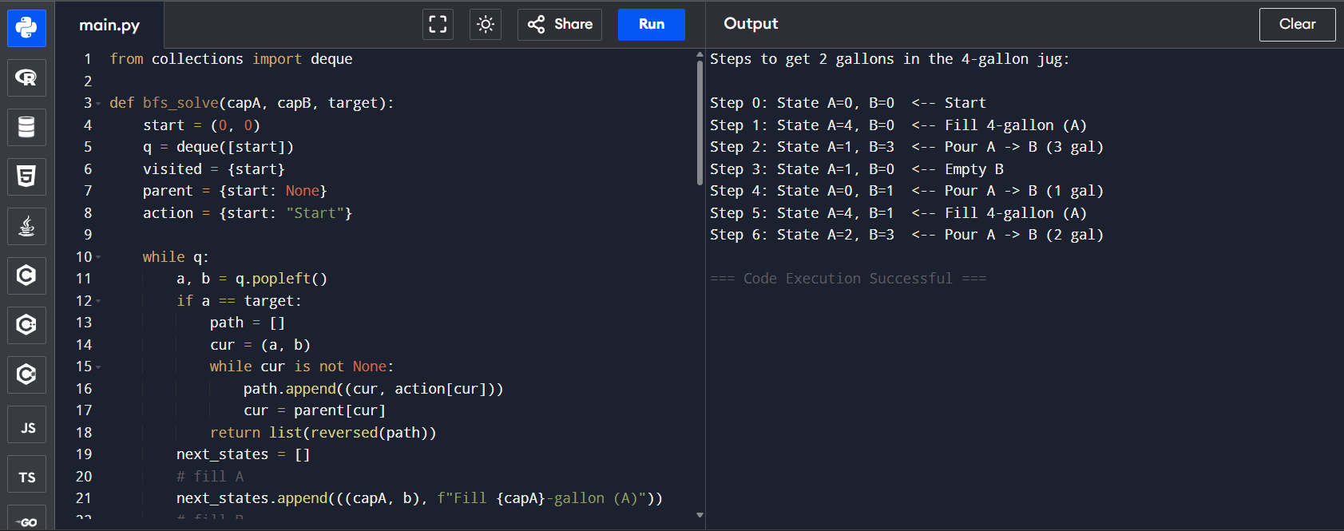

8.Code:
import re
from copy import deepcopy

def parse_atom(s):
s = s.strip()
m = re.match(r'([a-zA-Z_][a-zA-Z0-9_]*)\s*\((.*)\)', s)
if not m:
return (s, [])
pred = m.group(1)
args = [a.strip().strip('"') for a in re.split(r'\s*,\s*', m.group(2))] if m.group(2).strip() else []
return (pred, args)

def is_var(x):
return bool(x) and x[0].isupper()

def substitute_atom(atom, theta):
pred, args = atom
return (pred, [theta.get(a, a) if not is_var(a) or a not in theta else substitute_term(theta[a], theta) for a in args])

def substitute_term(x, theta):
if is_var(x) and x in theta:
return substitute_term(theta[x], theta)
return x

def unify_var(var, x, theta):
if var in theta:
return unify(theta[var], x, theta)
if is_var(x) and x in theta:
return unify(var, theta[x], theta)
if occurs_check(var, x, theta):
return None
new_theta = dict(theta)
new_theta[var] = x
return new_theta

def occurs_check(var, x, theta):
if var == x:
return True
if is_var(x) and x in theta:
return occurs_check(var, theta[x], theta)
return False

def unify(x, y, theta):
if theta is None:
return None
if x == y:
return dict(theta)
if is_var(x):
return unify_var(x, y, theta)
if is_var(y):
return unify_var(y, x, theta)
if isinstance(x, list) and isinstance(y, list) and len(x) == len(y):
t = dict(theta)
for xi, yi in zip(x, y):
t = unify(xi, yi, t)
if t is None:
return None
return t
return None

def rename_rule(rule, idx):
head, body = rule
mapping = {}
def ren(x):
if is_var(x):
if x not in mapping:
mapping[x] = f"{x}_{idx}"
return mapping[x]
return x
new_head = (head[0], [ren(a) for a in head[1]])
new_body = [(b[0], [ren(a) for a in b[1]]) for b in body]
return (new_head, new_body)

def backward_chain(kb_facts, kb_rules, goal):
agenda = [(goal, {})]
visited = set()
while agenda:
(g_pred, g_args), theta = agenda.pop()
g_sub = (g_pred, [substitute_term(a, theta) if is_var(a) else a for a in g_args])
key = (g_sub[0], tuple(g_sub[1]), tuple(sorted(theta.items())))
if key in visited:
continue
visited.add(key)
fact_matched = False
for f in kb_facts:
t = unify(g_sub[1], f[1], dict(theta)) if g_sub[0] == f[0] else None
if t is not None:
return True, t
for i, rule in enumerate(kb_rules):
head, body = rename_rule(rule, i)
if head[0] != g_sub[0] or len(head[1]) != len(g_sub[1]):
continue
t_head = unify(head[1], g_sub[1], dict(theta))
if t_head is None:
continue
success = True
t_curr = dict(t_head)
for lit in body:
res, t_new = backward_chain_with_theta(kb_facts, kb_rules, lit, t_curr, set())
if not res:
success = False
break
t_curr.update(t_new)
if success:
return True, t_curr
return False, None

def backward_chain_with_theta(kb_facts, kb_rules, goal, theta, visited):
g_pred, g_args = goal
g_sub = (g_pred, [substitute_term(a, theta) if is_var(a) else a for a in g_args])
key = (g_sub[0], tuple(g_sub[1]), tuple(sorted(theta.items())))
if key in visited:
return False, None
visited.add(key)
for f in kb_facts:
if f[0] != g_sub[0] or len(f[1]) != len(g_sub[1]):
continue
t = unify(g_sub[1], f[1], dict(theta))
if t is not None:
return True, t
for i, rule in enumerate(kb_rules):
head, body = rename_rule(rule, i)
if head[0] != g_sub[0] or len(head[1]) != len(g_sub[1]):
continue
t_head = unify(head[1], g_sub[1], dict(theta))
if t_head is None:
continue
t_curr = dict(t_head)
ok = True
for lit in body:
res, t_new = backward_chain_with_theta(kb_facts, kb_rules, lit, t_curr, visited)
if not res:
ok = False
break
t_curr.update(t_new)
if ok:
return True, t_curr
return False, None

if __name__ == "__main__":
raw_kb = [
"mammal(A) ==> vertebrate(A)",
"vertebrate(A) ==> animal(A)",
"vertebrate(A), flying(A) ==> bird(A)",
'vertebrate(\"duck\")',
'flying(\"duck\")',
'mammal(\"cat\")'
]

facts = []
rules = []
for clause in raw_kb:
if '==>' in clause:
left, right = clause.split('==>')
head = parse_atom(right)
body_atoms = [parse_atom(x) for x in left.split(',') if x.strip()]
rules.append((head, body_atoms))
else:
facts.append(parse_atom(clause))

queries = ['bird("duck")', 'animal("duck")', 'mammal("cat")', 'bird("cat")']
for q in queries:
goal = parse_atom(q)
res, theta = backward_chain(facts, rules, goal)
if res:
print(f"{q} -> TRUE, substitution: {theta}")
else:
print(f"{q} -> FALSE")
Output:
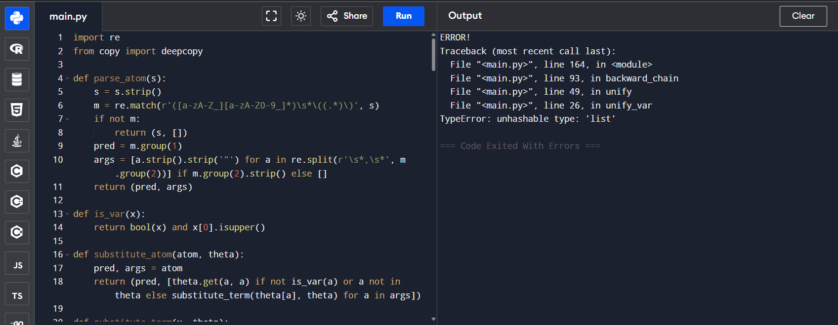
9.Code:
import numpy as np

np.random.seed(1)

def sigmoid(x):
return 1 / (1 + np.exp(-x))

def dsigmoid(x):
s = sigmoid(x)
return s * (1 - s)

def relu(x):
return np.maximum(0, x)

def drelu(x):
return (x > 0).astype(float)

class SimpleFFNN:
def __init__(self, n_in, n_hidden, n_out, activation='sigmoid'):
self.W1 = np.random.randn(n_hidden, n_in) * 0.5
self.b1 = np.zeros((n_hidden, 1))
self.W2 = np.random.randn(n_out, n_hidden) * 0.5
self.b2 = np.zeros((n_out, 1))
if activation == 'relu':
self.act = relu; self.dact = drelu
else:
self.act = sigmoid; self.dact = dsigmoid
self.out_act = sigmoid # for binary outputs

def forward(self, X):
Z1 = self.W1 @ X + self.b1
A1 = self.act(Z1)
Z2 = self.W2 @ A1 + self.b2
A2 = self.out_act(Z2)
cache = (X, Z1, A1, Z2, A2)
return A2, cache

def predict(self, X):
A2, _ = self.forward(X)
return (A2 > 0.5).astype(int), A2

def train(self, X, Y, epochs=5000, lr=0.1, verbose=False):
for epoch in range(epochs):
A2, cache = self.forward(X)
Xc, Z1, A1, Z2, A2 = cache
m = X.shape[1]

dZ2 = A2 - Y
dW2 = (1/m) * (dZ2 @ A1.T)
db2 = (1/m) * np.sum(dZ2, axis=1, keepdims=True)

dA1 = self.W2.T @ dZ2
dZ1 = dA1 * self.dact(Z1)
dW1 = (1/m) * (dZ1 @ Xc.T)
db1 = (1/m) * np.sum(dZ1, axis=1, keepdims=True)

self.W2 -= lr * dW2
self.b2 -= lr * db2
self.W1 -= lr * dW1
self.b1 -= lr * db1

if verbose and (epoch % (epochs//5) == 0 or epoch == epochs-1):
loss = np.mean((A2 - Y)**2)
print(f"Epoch {epoch:5d} Loss: {loss:.6f}")

if __name__ == "__main__":
X = np.array([[0,0,1,1],
[0,1,0,1]], dtype=float) # shape (2,4)
Y = np.array([[0,1,1,0]], dtype=float) # XOR targets shape (1,4)

net = SimpleFFNN(n_in=2, n_hidden=4, n_out=1, activation='sigmoid')

print("Outputs before training:")
_, out_before = net.predict(X)
print(out_before.round(3))

net.train(X, Y, epochs=8000, lr=0.5, verbose=True)

print("\nOutputs after training:")
preds, out_after = net.predict(X)
print(out_after.round(3))
print("Predicted classes:", preds.flatten())
print("True classes :", Y.flatten().astype(int))
Output:
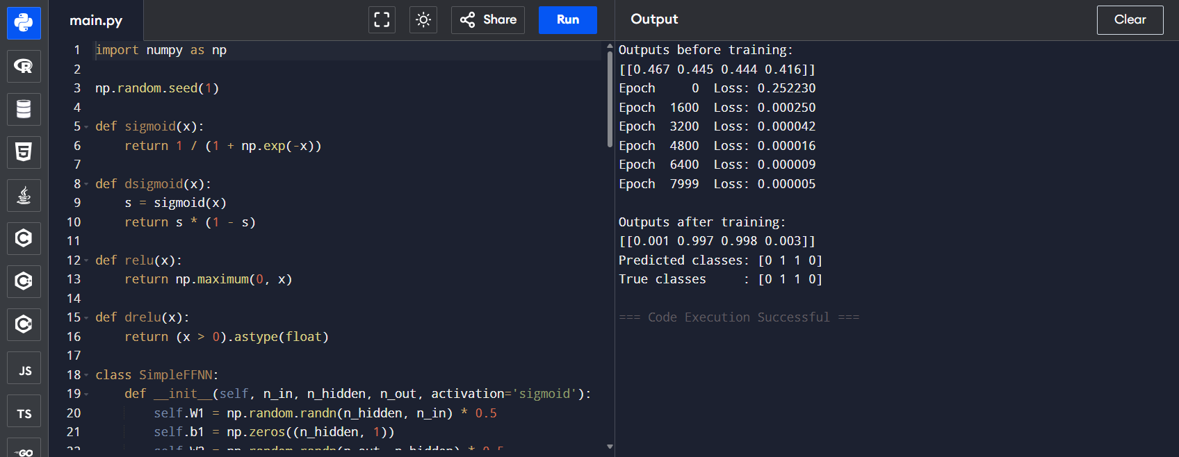
10.Code:
import copy
import math
import random
import time
import sys

def init_board():
board = [['.' for _ in range(8)] for __ in range(8)]
for r in range(3):
for c in range(8):
if (r + c) % 2 == 1:
board[r][c] = 'b'
for r in range(5, 8):
for c in range(8):
if (r + c) % 2 == 1:
board[r][c] = 'w'
return board

def print_board(b):
print(" " + " ".join(map(str, range(8))))
for r in range(8):
print(r, " ".join(b[r]))
print()

def in_bounds(r, c):
return 0 <= r < 8 and 0 <= c < 8

def opponent(p):
return 'w' if p == 'b' else 'b'

def piece_owner(x):
if x in ('b','B'): return 'b'
if x in ('w','W'): return 'w'
return None

def is_king(x):
return x in ('B','W')

DIRS = {
'b': [(1,-1),(1,1)],
'w': [(-1,-1),(-1,1)],
'king': [(-1,-1),(-1,1),(1,-1),(1,1)]
}

def find_noncaptures(board, r, c):
p = board[r][c]
res = []
dirs = DIRS['king'] if is_king(p) else DIRS[p.lower()]
for dr, dc in dirs:
nr, nc = r+dr, c+dc
if in_bounds(nr, nc) and board[nr][nc] == '.':
res.append({'start':(r,c), 'seq':[(nr,nc)], 'caps':[]})
return res

def find_captures(board, start):
r0, c0 = start
piece = board[r0][c0]
owner = piece.lower()
results = []
def rec(bd, r, c, path, caps):
found = False
cur = bd[r][c]
dirs = DIRS['king'] if is_king(cur) else DIRS[cur.lower()]
for dr, dc in dirs:
mr, mc = r+dr, c+dc
jr, jc = r+2*dr, c+2*dc
if in_bounds(jr,jc) and in_bounds(mr,mc):
mid = bd[mr][mc]
dest = bd[jr][jc]
if dest == '.' and mid != '.' and piece_owner(mid) == opponent(owner):
found = True
bd2 = copy.deepcopy(bd)
bd2[r][c] = '.'
bd2[mr][mc] = '.'
bd2[jr][jc] = cur
if not is_king(cur):
if (owner == 'b' and jr == 7) or (owner == 'w' and jr == 0):
bd2[jr][jc] = cur.upper()
rec(bd2, jr, jc, path+[(jr,jc)], caps+[(mr,mc)])
if not found and caps:
results.append({'start':start, 'seq':path, 'caps':caps})
rec(board, r0, c0, [], [])
return results

def get_all_moves(board, player):
caps = []
moves = []
for r in range(8):
for c in range(8):
if piece_owner(board[r][c]) == player:
cs = find_captures(board, (r,c))
if cs:
caps.extend(cs)
else:
moves.extend(find_noncaptures(board, r, c))
return caps if caps else moves

def apply_move(board, mv):
bd = copy.deepcopy(board)
sr, sc = mv['start']
piece = bd[sr][sc]
bd[sr][sc] = '.'
for cr, cc in mv['caps']:
bd[cr][cc] = '.'
if mv['seq']:
dr, dc = mv['seq'][-1]
else:
dr, dc = sr, sc
if not is_king(piece):
if piece.lower() == 'b' and dr == 7: piece = 'B'
if piece.lower() == 'w' and dr == 0: piece = 'W'
bd[dr][dc] = piece
return bd

def game_over(board):
b_exists = any(board[r][c] in ('b','B') for r in range(8) for c in range(8))
w_exists = any(board[r][c] in ('w','W') for r in range(8) for c in range(8))
if not b_exists: return True, 'w'
if not w_exists: return True, 'b'
if not get_all_moves(board, 'b'): return True, 'w'
if not get_all_moves(board, 'w'): return True, 'b'
return False, None

def evaluate(board, player):
b_score = 0
w_score = 0
b_moves = len(get_all_moves(board, 'b'))
w_moves = len(get_all_moves(board, 'w'))
for r in range(8):
for c in range(8):
p = board[r][c]
if p == 'b': b_score += 3 + (r*0.03)
if p == 'B': b_score += 5
if p == 'w': w_score += 3 + ((7-r)*0.03)
if p == 'W': w_score += 5
b_score += 0.1*b_moves
w_score += 0.1*w_moves
return b_score - w_score if player=='b' else w_score - b_score

def minimax(board, depth, alpha, beta, maximizing, player, start_time=None, time_limit=None):
over, winner = game_over(board)
if over:
if winner == player: return math.inf, None
return -math.inf, None
if depth == 0: return evaluate(board, player), None
cur_player = player if maximizing else opponent(player)
moves = get_all_moves(board, cur_player)
if not moves:
return (-math.inf if maximizing else math.inf), None
best_move = None
if maximizing:
value = -math.inf
moves.sort(key=lambda m: len(m['caps']), reverse=True)
for mv in moves:
if time_limit and time.time()-start_time>time_limit: break
nb = apply_move(board, mv)
val, _ = minimax(nb, depth-1, alpha, beta, False, player, start_time, time_limit)
if val > value:
value = val; best_move = mv
alpha = max(alpha, val)
if beta <= alpha: break
return value, best_move
else:
value = math.inf
moves.sort(key=lambda m: len(m['caps']), reverse=True)
for mv in moves:
if time_limit and time.time()-start_time>time_limit: break
nb = apply_move(board, mv)
val, _ = minimax(nb, depth-1, alpha, beta, True, player, start_time, time_limit)
if val < value:
value = val; best_move = mv
beta = min(beta, val)
if beta <= alpha: break
return value, best_move

def choose_move(board, player, max_depth=4, time_limit=1.0):
start = time.time()
best = None
for d in range(1, max_depth+1):
val, mv = minimax(board, d, -math.inf, math.inf, True, player, start, time_limit)
if time.time()-start > time_limit: break
if mv is not None: best = mv
return best

def human_move(board, player):
moves = get_all_moves(board, player)
if not moves: return None
for i, mv in enumerate(moves):
seq = " -> ".join(f"({r},{c})" for r,c in [mv['start']] + mv['seq'])
caps = f" captures {len(mv['caps'])}" if mv['caps'] else ""
print(f"{i}: {seq}{caps}")
while True:
choice = input("Enter move index (q to quit): ").strip()
if choice.lower() == 'q': sys.exit(0)
if choice.isdigit():
idx = int(choice)
if 0 <= idx < len(moves): return moves[idx]
print("Invalid")

def play(human_side='w', ai_side='b', ai_depth=5, ai_time=1.0, ai_vs_ai=False):
board = init_board()
cur = 'b'
print_board(board)
while True:
over, winner = game_over(board)
if over:
print("Winner:", winner)
break
actor = "AI" if (ai_vs_ai or cur==ai_side) else "Human"
print(cur, "turn", actor)
if not ai_vs_ai and cur != ai_side:
mv = human_move(board, cur)
else:
mv = choose_move(board, cur, max_depth=ai_depth, time_limit=ai_time)
if mv is None:
moves = get_all_moves(board, cur)
mv = random.choice(moves) if moves else None
if mv is None:
print("No move available")
break
board = apply_move(board, mv)
print_board(board)
cur = opponent(cur)

if __name__ == "__main__":
print("1 Human(white) vs AI(black)\n2 Human(black) vs AI(white)\n3 AI vs AI")
mode = input("Choose 1/2/3 (default 1): ").strip() or "1"
if mode == "1": play(human_side='w', ai_side='b', ai_depth=5, ai_time=1.0)
elif mode == "2": play(human_side='b', ai_side='w', ai_depth=5, ai_time=1.0)
else: play(ai_vs_ai=True, ai_depth=4, ai_time=0.8)
Output: 